Cooperative Games and Conflict Resolution Skills for Primary Schools Facilitation Workshop:
for working with groups of young people, 5 – 12 years old.

Date & Time: Saturday 8 October, 10am – 5:30pm.

Participants: teachers and youth workers in a variety of contexts interested in Nonviolence Education & Cooperative Activities

Where: City Centre venue to be confirmed upon registration
Content: theory, skills & practical approaches - team building, cooperative games & group dynamics, based on the Peace and Justice Centre facilitators’ experience of delivering Cooperative Games and Conflict Resolution Workshops at an Edinburgh Primary School in 2015-16. Supports Curriculum for Excellence Health and Wellbeing outcomes.
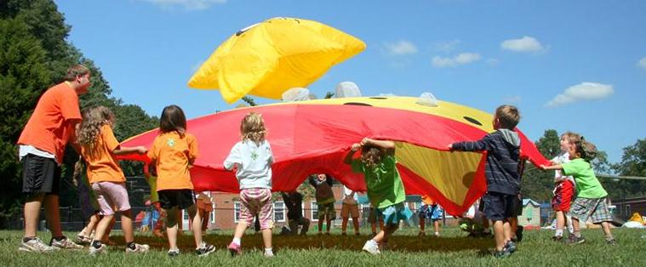 •Understanding me and others
•Managing my anger
•Improving my communication
•Understanding my skills to manage conflict

Workshop participants will be eligible to participate in further practical training, co-delivering the Cooperative Games and Conflict Resolution Skills for Primary Schools Project with an experienced facilitator, to practise the skills acquired in the workshop and lead activities with children. Upon completion of the training participants will be awarded a certificate in Cooperative Games and Conflict Resolution and will be eligible to work as Facilitators to deliver the programme to schools. Professionals already working in the field may be eligible to bypass the practical training.
Dates for Training in Schools: Four of the following: Tuesdays 25 October – 13 December
Course fee - pay what you can – recommended donation £30 for 7.5 hour training workshop including tea, coffee, snacks and lunch.
Advance booking required. Book by 5pm Friday 30 September
Places are limited. For more information telephone 0131 629 1058 or email contact@peaceandjustice.org.uk To book a place please complete the following form and return to the same email address.
Payment can be made by cheque made out to “Edinburgh Peace and Justice Centre” enclosed with registration form, via PayPal on our website using the Donate button and putting “Cooperative Games Workshop” in “Purpose” field, or in cash on the day. Deposit requested.
Registration for Cooperative Games and Conflict Resolution Skills Facilitation Workshop:
Saturday 8 October, 10am – 5pm.
City Centre venue will be confirmed by end of 3 October!
Name

Email address

Mobile number

Workplace

Dietary needs
Accessibility needs
Learning needs
Any relevant experience
Can you please say a few words about :
why you’re interested in this workshop, what you hope to gain and how you will use the skills:

